**SALES AND INVENTORY MANAGEMENT SYSTEM**



**Submitted by**

Nimra Zahra

2018-KIU-802

**Supervised by**

Dr. Dosdar Hussain

**Department of Computer Science, KIU, Gilgit.**

May 25, 2022

Sales and inventory management system Karakorum international university

By

Nimra Zahra

2018-KIU-802

A project submitted in partial fulfillment of the requirement for the degree of BS In

Software Engineering

Department of Computer Science, KIU, Gilgit.

(2018-2021)



**IN THE NAME OF ALLAH WHO IS THE MOST BENEFICENT AND MOST MERCIFUL**

CERTIFICATE OF APPROVAL

This Project “SALES AND INVENTORY MANAGEMENT SYSTEM)” is hereby approved in partial fulfillment of the requirement for the degree of Bachelor of Science in Computer Sciences at Karakorum International University Gilgit-Baltistan.

#### Supervised by,

AP Dr. Dosdar Hussain

Signature________________

Head of Department External Examiner

Dr. Zarnawab

Signature Signature _______________

## **DEDICATION**

First, we dedicate this modest effort to God Almighty who is our initiator, our powerful foundation, my fondness of information and understanding. He has been the source of our strength throughout this research. we also dedicate this work to our beloved parents, all our respectable teach and caring and loving friends who are a source of unremitting encouragement and motivation for us and whose love, warmth, support and guidance permitted us to complete this thesis and accomplishment in life.

## **DECLARATION**

We declare that this project is a showcase of our own work that has not been submitted for any awards. We also warrant that we have not received outside assistance or been involved in external contributions; if we have received or been involved in external contributions, we will acknowledge it in writing to authorities; otherwise, we will be liable for the cancellation of our thesis and, as a result, the degree that will be awarded.

|  |  |
| --- | --- |
| Signature  Student Name: Nimra Zahra  Reg: 2018-KIU-802  Date: May 25, 2022 | Signature  Supervisor Name: Dr. Dostdar Hussain  Date ______________________________ |

## **ACKNOWLEDGMENTS**

We would like to use this opportunity to express our gratitude to Allah, the Almighty, for bestowing his favor upon us for concluding our project. Our sincere and heartfelt gratitude goes out to our renowned guide, DR. DOSTDAR HUSSAIN, for giving us sound advice and guidance at critical times and for pointing us in the correct direction. We want to take this occasion to thank our co-supervisor, MR. ISRAR HUSSAIN, for his help and support. We would like to express our gratitude to our friends and family for their unwavering support and encouragement throughout our careers.

## **ABSTRACT**

The goal of the retail industry is to make as much money as possible from client satisfaction.

Customers will be more loyal to the store if they receive more personalized attention. However, if a retail shop does not have enough inventory, it is easy to lose a potential consumer. Thus, in this application, the developer recognized a problem with inventory that exists in stores. The store's main issue is that they don't have a proper inventory control system in place to guide and manage its sales and inventory levels.

The project seeks to provide a system with expanded and more flexible functionalities to the shop by presenting a Sale & Inventory Management System as a substitute for previous manual methods. The system's goal is to give capabilities for more efficient inventory management in the store. The scope of the project will focus on issues such as database, report generation, quality control (QA), and the store's point of sale in order to meet the established objectives. Furthermore, the system will be developed using an offline system or a window-based system.

The phase development prototype is chosen when designing the system. This methodology highlights the scope of the project by performing the development stage in accordance with modules. As a result, the system will be developed version by version before the entire system is ready to use. The system's planned outcome is that the user interface that will be designed would be user-friendly, allowing those without an IT background to utilize it with ease. Furthermore, the system is intended to perform its responsibilities and assist Stores in minimizing time and paperwork associated with inventory management.

Table of Contents

**DEDICATION** 5

**DECLARATION** 6

**ACKNOWLEDGMENTS** 7

**ABSTRACT** 8

**CHAPTER 1** 11

**INTRODUCTION** 11

1.1 PROJECT BACKGROUND 11

1.2 PROBLEM STATEMEN 12

**1.2.1** **Problem Identification** 12

1.3 OBJECTIVES 13

1.4 RESEARCH LIMITATION 14

1.5 PROJECT FEASIBILITY WITHIN SCOPE & TIME FRAME 14

**CHAPTER 2** 15

**LITERATURE REVIEW** 15

2.1 SALES AND INVENTORY MANAGEMENT SYSTEM: 15

HISTORY AND CONCEPTS 15

2.2 ASSESSING THE BENEFITS OF THE BARCODE TECHNOLOGY 16

2.3 ADVANTAGES OF SALE AND INVENTORY MANAGEMENT SYSTEM 17

2.4 POINT OF SALE (POS) CONCEPTS AND USAGE 18

**CHAPTER 3** 19

**METHODOLOGY** 19

3.1 RAPID APPLICATION DEVELOPMENT (RAD) METHODOLOGY 19

3.2 PROJECT PHASES 20

3.4 TOOLS, MECHANISMS AND SOFTWARE 22

3.5 Feasibility Analysis 22

**CHAPTER 4** 26

**RESULTS AND DISCUSSION** 26

4.1 THE FRAMEWORK OF THE SYSTEM 26

4.2 Flow Chart 26

4.3 Use Case Diagram for Admin 29

4.4 Entity Relation Diagram 32

4.5 PROTOTYPE APPLICATION 34

4.6 SYSTEM TESTING 39

**CHAPTER 5** 43

CONCLUSION 43

REFERENCES 44

APPENDICES 45

List Of Figures

Figure 1 Flow Chart for Admin 27

Figure 2: flow Chart for User 28

Figure 3: Use-Case Diagram for admin of Sales & Inventory Management System 30

Fig 4: Use-Case Diagram for user of Sales & Inventory Management System 31

Fig 5: Entity Relationship Diagram 33

Figure 6: User Login Page 34

Figure 7: Content Page (Admin View) 35

Fig 8: Add New Item 36

Figure 10: Manage Order 37

Figure 11: Add New Customer 38

Figure 12: New Order 39

Figure 13: Stock Details 39

Figure 14: Effectiveness of System 41

Figure 15: Reflection of System toward User 41

Figure 16: Respond toward Generated Report 42

Figure 17: Customer Testing Outcome 43

## **CHAPTER 1**

## **INTRODUCTION**

### 1.1 PROJECT BACKGROUND

The retail industry is one of the industries that is growing in fast pace where the number of retail business keep on increasing from time to time in order to meet the demand from consumers of specified areas. There are different types of retail shops available for consumer to choose ranging from hypermarket to mini market according to their convenience. Most of the shops can be found in residential areas, streets, or in a shopping mall. Basically, retail store sells wide range of goods and services from wholesaler or supplier to the end-user. Thus, the nature of retail business required a good management of inventory level in order to meet the demand of the customers.

Traditional spreadsheets are used by retailers to keep track of sales and inventory, but they become ineffective when the company grows in size. This is because more things will be available in larger quantities, making it difficult and time consuming for the merchant to track sales based on inventory levels in the store. Furthermore, the problem deteriorates when the shop lacks a reliable way for determining the things purchased by their customers.

As a result, this project will give a solution for shops who still use old methods.

In the same way as 'Candela' created an inventory system, they have a technique of preserving their inventory data.

### 1.2 PROBLEM STATEMEN

## **1.2.1 Problem Identification**

Inventory is one of the key departments that must be well-managed in order to achieve success to ensure that day-to-day business operations execute smoothly However, because they do not have a computerized system to run their business, the store still does not understand the need of inventory management. As a result, all data, documents, and everything else linked to everyday transactions and inventory have a very poor level of protection. Many records have been kept for each item and each supplier, which takes up a lot of time and is ineffective for future references. Furthermore, due to inadequate sales and inventory management, the store has difficulty determining the quantity sold every day for each item and the available inventory level of the items. Existing inventory management systems also lack the ability to detect expiration dates for food items such as milk, bread, flour, and so on. Failure to recognize the expiration date of certain products results in store losses.

To calculate the overall amount of each, the current system simply works as a calculator.

Because there is no database relationship between the customer's purchases and the system, the system is unable to provide a report on point of sale at the end of the day. As a result, there is no standard procedure for creating reports in the store's log book, resulting in different types of reports being generated each time. The simple report which is about the total sales of the days determined based on amount of money in the cashier deck does not provide any input for the owner to make the right decision regarding the business operation in case of there is short of cash in the cashier desk or any stolen cases, the owner cannot detect it as the current system does not have database to store the total sales of the day.

#### **1.2.2 Significance of the project**

This new system will have a database that will allow data to be stored storing and retrieving each transaction as well as inventory data for each item in the shop, managing product releases and storage, and summarizing point of sale transactions. This would result in quicker work improvisation with less time and effort. This system is supposed to assist in making the appropriate decision in the process of managing inventory aligned with the sales level in the shop, since the objective of Sales and Inventory Management System is to decrease paper effort and ineffective ways of managing inventory.

### 1.3 OBJECTIVES

Because the current system only offers a few features to the user, this is a good idea.

The store will have improved and more flexible capabilities as part of the makeover. Among the goals are

1. To provide a function for more efficiently managing goods in the store. Basic for data administration, functions such as 'add,' 'delete,' and 'update' will be provided.
2. A filling system for maintaining all relevant transactions and paperwork as an assist in stock tracking routines.
3. To generate a weekly report on sales and inventory activity automatically.
4. To send out notifications about the goods' expiration dates in order to facilitate clearance action.
5. Create a receipt in the correct format for customer reference.

### 1.4 RESEARCH LIMITATION

• There is no way to verify the status of new requests.

The system does not have a way to check requests for new items, which makes the requesting process incomplete because the user must manually check it.

• Absence of a decision-making aid

The system does not evaluate the data captured in the database, such as providing the user with patterns of client buying behavior but it does have the ability to retrieve the data in the form of a report.

### 1.5 PROJECT FEASIBILITY WITHIN SCOPE & TIME FRAME

In the development of a project, time and scope are intertwined constraints. The scope of the system has been cut down to solely inventory control via daily sales during development, allowing the developer adequate time to conduct preliminary research and create the project. Only sales and inventory system research will be done, and it is expected to be completed within the time range.

The research also includes a review of the literature in order for the developer to gain a thorough understanding of the topic domain within a reasonable time limit. Furthermore, experience gained from a part-time employment in a retail store known as '100 Yen' in handling sales and inventory systems is quite beneficial in comprehending the breadth. Preliminary study is expected to take three months, while system development is expected to take four months. It is critical to keep the project focused and have a defined structure in order to reduce the project's failure risks.

## **CHAPTER 2**

## **LITERATURE REVIEW**

### 2.1 SALES AND INVENTORY MANAGEMENT SYSTEM:

### HISTORY AND CONCEPTS

Every day, millions of people throughout the world participate in innumerable sales transactions.

ensuring a continuous flow of value, which is the foundation of our economies in general, a sale is a transaction between two parties in which the buyer obtains real or intangible products, services, or assets in exchange for money. As a result, each party must give up something in exchange for something useful to them. Inventory, on the other hand, refers to the raw materials, work-in-process items, and finished goods that make up the fraction of a company's assets that can be sold. This explains why a business requires inventory to make sales to customers in exchange for money, which generates profits.

High inventory and low inventory are two types of problems that businesses confront while managing inventory levels. Because of the costs of inventory storage, obsolescence, and spoilage, keeping a large quantity of inventory for an extended period of time is usually not a good idea for a firm. Low inventory, on the other hand, is not beneficial because the company risks losing potential sales and market share. When it comes to fixing inventory issues, the key is effective inventory management.

Inventory management systems are the rule in understanding which products are selling and which are taking up shelf space for companies as well as smaller firms and suppliers, according to Tim Crosby (2012) in his paper on 'How Inventory Management Systems Work.' The strategy strikes a balance between ensuring that customers always have enough of what they want and a retailer's financial necessity to keep as little inventory as feasible (Tim Zierden,2009). As a result, the capacity to keep track of sales and available inventory, as well as connect with customers, is essential Modern inventory management systems must be able to communicate with suppliers in near real-time and receive and incorporate other data such as seasonal demand.

Another new technology for inventory tracking emerges as technology advances.

In recent years, it has found its way into supermarkets, warehouses, and factories (Edward A. Silver, 2007). A microchip is used to convey product information to a scanner or other data collection device using radio frequency identification (RFID). As a result, the constant 'beep, beep, beep' of bar codes being read at the checkout lane indicates current inventory management and stock tracking systems.

### 2.2 ASSESSING THE BENEFITS OF THE BARCODE TECHNOLOGY

According to Ervin Shahin & Yves Daley (2010) in their study paper titled "The Impact of the Use of Bar Code Technology on Supply Chain Operations," the bar code system is one of the most extensively used data capture technologies in practically every business. By using the barcode sector, the supermarket industry, for example, was able to gain hard and soft revenue savings of 2.67 percent and 2.89 percent respectively the typical goals in adopting the barcode system are to reduce data capture mistakes, capture timely data for inventory control, improve communication between buyers and sellers, and improve customer service. Furthermore, the system acts as a primary source of real-time input, allowing organizations to monitor operations, manage resources, and identify irregularities before they impair throughput.

Several studies have been conducted on how barcode applications can help supply chains. One of the studies is a qualitative study that explains the notion of bar code technology and creates conceptual approaches to help people comprehend it better. Barcode systems have a key role in improving inventory management effectiveness, according to case studies conducted in distribution and manufacturing organizations Less capital is locked up in inventory, inventory control is improved, customer service is improved, and staff are empowered, according to the studies.

### 2.3 ADVANTAGES OF SALE AND INVENTORY MANAGEMENT SYSTEM

As the advantages of switching to modern inventory control system clearly proven by many businesses, it is the time for store to start implementing it in their store to see the differences will be brought to the store. In Donald Reimer (2008) in his study with the title of ‘Computerization is the key in maintaining proper inventory levels’ identified few benefits as follows

• ***Inventory*** ***management*** ***increases*** ***profitability***

Forecasting, controlling, and managing inventory boost the store's sales and production, leading increased profitability. Furthermore, inventory accuracy improvements will reduce the cost of correcting costly mistakes. The system will also improve spend management by providing rapid access to current and historical pricing, cross-referenceable product codes, and capabilities for controlling purchasing operations.

• ***Inventory*** ***management*** ***improves*** ***cash*** ***flow***

Buying the proper inventory in the right amount to meet consumer demand while also getting rid of slow-moving, outmoded inventory improves cash flow and, eventually, earnings.

• ***Inventory*** ***management*** ***improves*** ***decision-making***

Rapid, reliable data collecting allows for real-time business intelligence across all sections of the store. Not only that, but the system's integration of issues and occurrences allows for proactive identification and resolution of problems.

• ***Inventory*** ***management*** ***increases*** ***customer*** ***satisfaction***

By keeping the correct products in store for clients, you can anticipate seasonal promotions and shifting marketing conditions.

### 2.4 POINT OF SALE (POS) CONCEPTS AND USAGE

Tim Badarin’s article 'Bringing the Checkout Counter to You' was published in June of 2013. A checkout counter or cashier stand is a station or aisle where people transport and place things they've chosen to buy from the store. The standard checkout procedure is for the cashier to scan and ring up each item on the cash register before calculating the total. The transactions at the checkout are handled by a point-of-sale system that the retailer chooses based on its requirements. According to Karen Kaplan, who wrote an article for the Los Angeles Times titled "Do-It-Yourself Solution: Small Grocery Chain Has Big Plans for Its Retailing Software," the POS phrase refers to the checkout counter in a store where customer and store transactions can take place. The term "point of sale" is frequently used in reference to the hardware and software used at checkout counters. Since their technological integration, POS systems have been used in a variety of industries, including restaurants, hotels & hospitality firms, casinos, salons, and retail spaces.

Currently, the majority of retail POS systems are the most advanced, powerful, and user-friendly Commercial computer networks that are user-friendly. Furthermore, POS systems perform a variety of tasks POS solutions that feature fully integrated accounting, inventory monitoring & management, open-to-buy forecasts, customer relation management (CRM), service management, rental services, operation reporting, and payroll modules are available in addition to POS activities (Quorion,2011). Nowadays, POS software is only as good as its ability to integrate with a wide range of popular products and services.

## **CHAPTER 3**

## **METHODOLOGY**

### 3.1 RAPID APPLICATION DEVELOPMENT (RAD) METHODOLOGY

In order to provide easy user and developer interaction with varied IT backgrounds, the author chose to adopt one of the 'rapid application development (RAD)' - based technique categories when designing the system. The RAD-based methodology enables the SDLC phases to be adjusted in order to get specific parts of the system produced rapidly and into the hands of the users. As a result, users will have a better understanding of the system and will be able to offer changes that will bring the system closer to what is require.

The advantage of phased development-based techniques is that they may swiftly get a viable system into the hands of users, allowing them to gain business value sooner. Furthermore, because users start using the system sooner, they are more likely to notice crucial extra requirements. These are some of the factors that influenced the author's decision to use this methodology in the development process.

### 3.2 PROJECT PHASES

There are basically four phases in the project activities which comprise of:

1. ***Planning:***

- The problem that the chosen shop is experiencing is identified, and a solution is suggested.

- The project's objectives and scope are clearly specified.

- The project activities are scheduled according to the time frame.

***ii.*** ***Analysis:***

- Data is acquired and literature analysis is completed.

- Store interviews are done for the goal of gathering requirements.

***iii.*** ***Design:***

- Project model and prototype are designed. - UML diagrams are designed.

1. ***Implementation:***

- Project coding is started till the system is finished

- Testing is done to ensure the project's usability

- It is made available to the user

**3.3 DATA COLLECTION METHODS**

Research and information collecting are important in the beginning of the project. Two

the following are the research methodologies employed in the project:

1. ***Interview***

interviewing the store owner to see whether the system is beneficial to them and to learn more about the system's requirements.

1. ***Searching*** ***on*** ***the*** ***Internet***.

Having a basic understanding of existing sales and inventory systems, as well as how to set up broad inventory monitoring system

### 3.4 TOOLS, MECHANISMS AND SOFTWARE

In the second part of the project, tools that are used to develop the system are as follows:

***i.*** ***Microsoft*** ***Visual*** ***Studio***

Microsoft Visual Studio is an integrated development environment (IDE) from Microsoft. It is used to develop console and graphical user interface applications in both native code and managed code for all platforms supported by Microsoft Windows, Windows Mobile, Window CE, .NET Framework, .NET Compact Framework and Microsoft Silverlight.

1. ***Microsoft*** ***Access***

Microsoft Access also known as Microsoft Office Access is a database management system from Microsoft that combines the relational Microsoft Jet Database Engine with a graphical user interface and software-development tools. It is a member of the Microsoft Office suite of application included in the Professional and higher editions. Microsoft Access is used to develop application software and supported by Visual Basic for Applications.

***iii.*** ***Online*** ***Project*** ***Management*** ***(Smartsheet.com)*** ***iv.*** ***Diagram*** ***Tools*** ***(Draw.io)***

***v.*** ***Microsoft*** ***Project*** ***Professional*** ***Office***

### 3.5 Feasibility Analysis

1. **Technical** **Feasibility**

In the development of a system, the technical aspect is the most significant. Because the system is offline, visual basic will be utilized to create the user interface and database functionalities. Microsoft Access will be utilized for the database, which will connect the system interface to the data storage.

The author's experience to the subject of 'Business System Development' gained through the course curriculum has given him the confidence to design the software as stated. Furthermore, there are numerous online tutorials on system creation available on the internet that will assist the author during the development stage.

1. **Economic** **Feasibility**

The project's economic feasibility has been investigated using basic analysis. According to the financial analysis, the new system will have a favorable economic feasibility. In terms of software design and licensing it can be available on open source on the Internet, so the owner does not have to buy it from a vendor.

1. **operational** **Feasibility**

Because the users/staff have never utilized a computerized system, the risk of familiarity with the application is moderate. As a result, in order to implement the system, a quick introduction to handing the system is required. Furthermore, because the majority of the store's employees are not computer educated, the to-be system will be user-friendly and simple to operate.

***Administrator:***

Inventory data will be easy to access and change for the administrator. To keep track of the store's performance, he prints out daily and weekly statistical reports.

**3.6 ANALYSIS**

#### **3.6.1 Non-Functional Requirements**

• **Operational Requirements**

It is necessary to run the system on a computer. Because Store lacks one, they must purchase one in order to install the system. It must be able to update the database based on each customer's point of sale. Furthermore, the system may provide sales reports on a daily, weekly, and monthly basis

• **Performance** **Requirements**

This system should load information in no more than 5 seconds and respond to user input in no more than 2 seconds.

• **Security** **Requirements**

Apart from those who are responsible for processing clients' sales at the cashier, not all employees have access to the system. The sales data is kept private and only the admin has access to it.

• **Cultural** **and** **Political** **Requirements**

There will be no unique cultural or political prerequisite

#### **3.6.2 Functional Requirements**

• Log In

• Process sale

Allow the user to scan each customer's purchases. The system will show the item descriptions, process the total purchases, and issue receipts to the customers.

• **Tracking inventory level**

Admin may keep track of each item's inventory level in relation to sales.

• **Update database**

Allow the administrator to make changes to the inventory data in the database, which will be utilized to process sales.

• **Generate report**

Reports on the store's daily, weekly, and monthly sales will be generated so that the owner may

assess the business's performance and take appropriate action.

## **CHAPTER 4**

## **RESULTS AND DISCUSSION**

### 4.1 THE FRAMEWORK OF THE SYSTEM

Here are some of the users:

• System administrators who can log in and change product information.

• Sales staff who are in charge of processing sales.

The system will include:

**.** An intuitive user interface

**.** A database: to keep track of everything

Users will engage with the system by providing inputs through an interface. The system will then process the input and provide the information required based on the information provided. In addition, the system keeps the user's processed data in a database.

### 4.2 Flow Chart

The flow chart is an important part of describing a model in manner way with the help of different symbols used for different functionalities, it is a step-by-step procedure to solve a problem. The different shapes used for purpose of start operation (Oval shape), process operation (rectangle shape), decision making (diamond shape) and lines to show the flow of data. These symbols help us to understand the flow of data very easily and a user with less knowledge can also understand the purpose of drawing a flowchart.

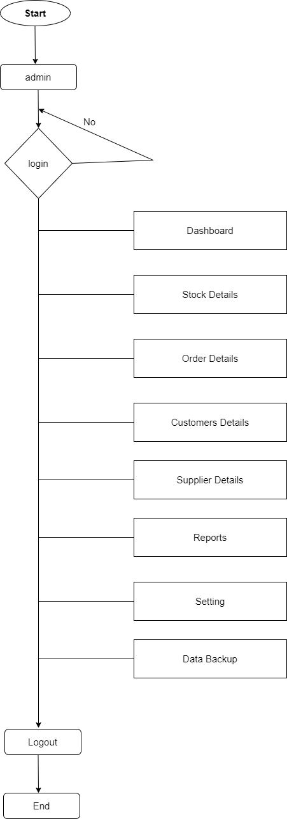

Figure : Flow Chart for Admin

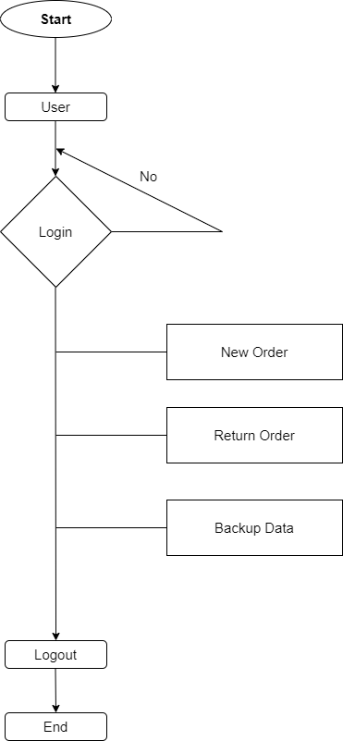

Figure 2: flow Chart for User

In general, the proposed Sales & Inventory Management System has one primary activity diagram (Figure 1) that leads to two additional activities created from the main activities. The activity began when a consumer chose products and brought them to the cashier for payment, so initiating the sale for that transaction. The user will complete the transaction by scanning each item's barcode, and the system will collect the item's description and price, which will be shown on the Point of Sale. A list of items will be produced, and new items will be added to the list as they become available. Finally, the total will be determined by the system, and the clients will be charged.

The transaction receipt will be printed and handed to the customer once payment has been made. At the same time, after the sales are completed, additional two processes will take place: updating the inventory and updating the finance section. The financial section of the store is updated in the way indicated in Figure 2. system that tracks the total amount of money spent by each customer The update will happen on a daily basis on a temporary table before being applied to the main database at the end of the day. Figure 2 depicts how each client transaction's information is recorded and used to update the inventory.

### 4.3 Use Case Diagram for Admin

A use case diagram describes and representation of a user's interaction with the system that shows the relationship between the user and the different use cases in which the user is involved.

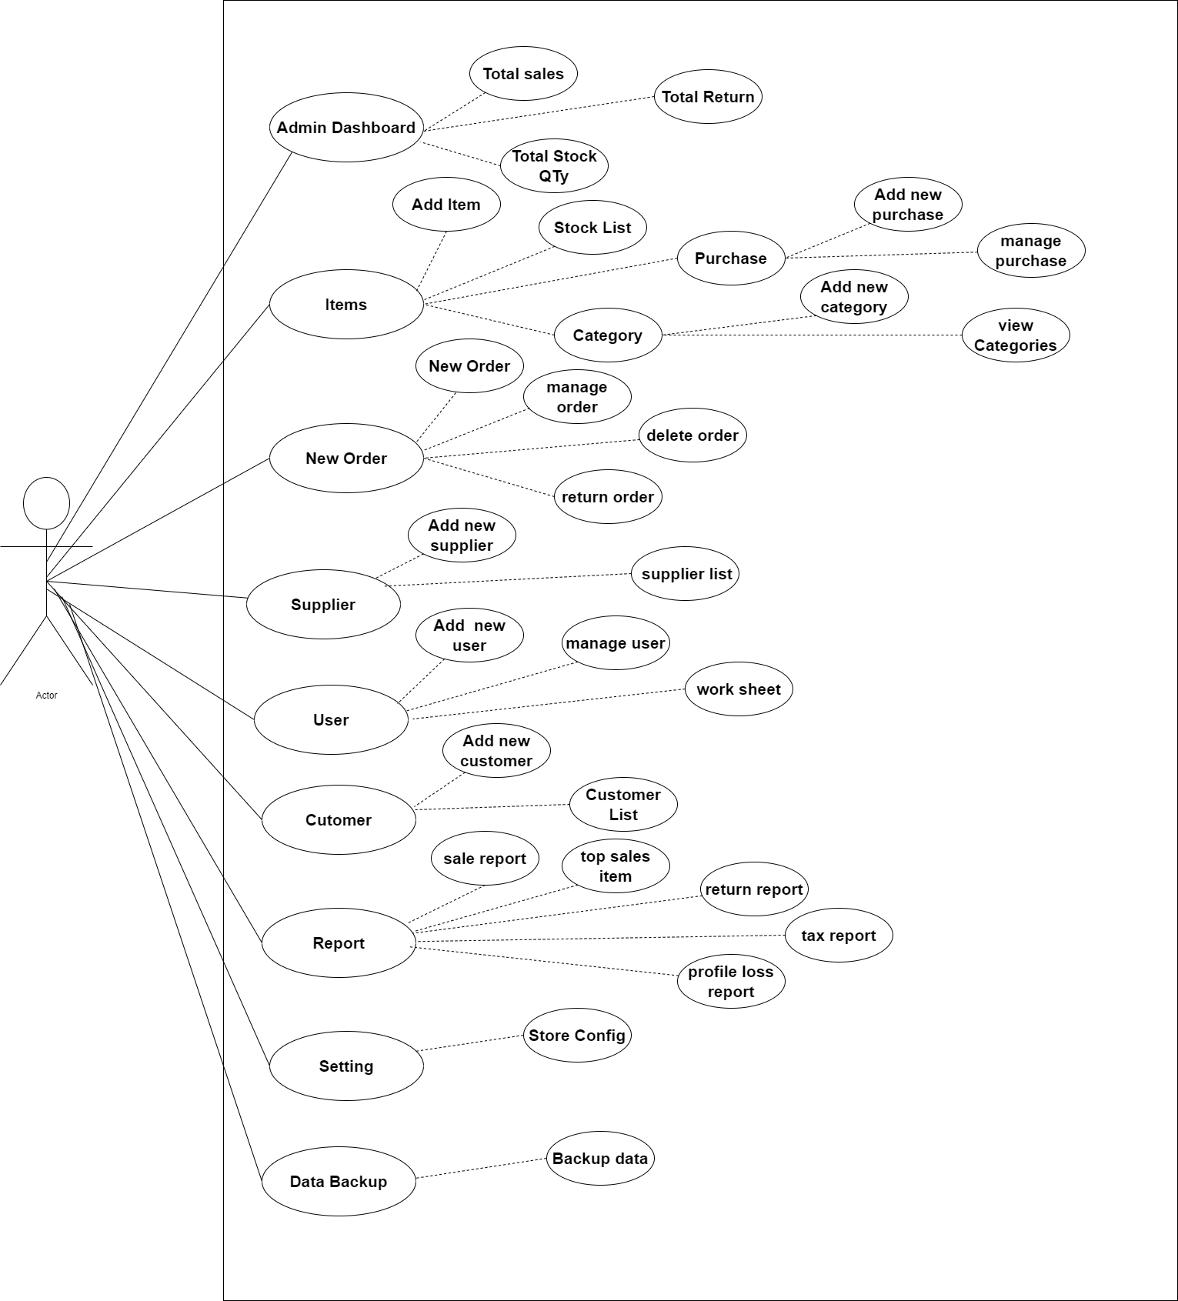

Admin

Figure 3: Use-Case Diagram for admin of Sales & Inventory Management System

Figure 3 depicts a use-case diagram, which is a graphical representation of the system's use scenarios. The diagram depicts a system's main functionality as well as the actors who interact with it. Users, administrators, and consumers are the three major actors in the diagram who extract value from the system, and the use case represents the system's functionality. The front-end functions are mostly handled by the user, while the back-end operations, such as data entry, are handled by the administrator. Customer on hand to assist with the user-linking function.

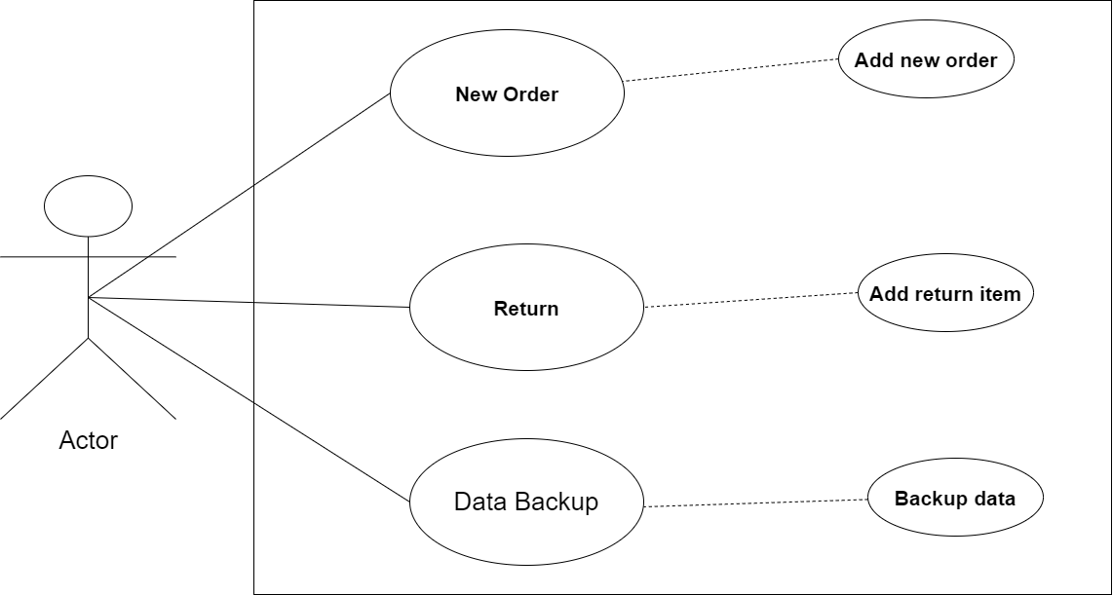

Fig 4: Use-Case Diagram for user of Sales & Inventory Management System

### 4.4 Entity Relation Diagram

The Entity Relationship Diagram (Figure 5) depicts the database that will be created for the system. Each class will collect and store data that will be needed in the Store's operations. Each class has attributes that describe the object's properties and state. Some of the classes additionally have actions or functions that can be performed by the class. In addition, the figure depicts the relationship between two classes.

Figure 4 depicts a use-case diagram, which is a graphical representation of the system's use scenarios. The diagram depicts a system's main functionality as well as the actors who interact with it. Users, administrators, and consumers are the three major actors in the diagram who extract value from the system, and the use case represents the system's functionality. The front-end functions are mostly handled by the user, while the back-end operations, such as data entry, are handled by the administrator. Customer on hand to assist with the user-linking function.

The database that will be built for the system is depicted in the Entity Relationship Diagram (Figure 5). Each class will collect and store information that will be needed in the operations of the shop. Attributes describe the qualities and state of an object in each class. Some classes feature additional actions or functions that can be used by the class. Furthermore, the diagram shows the relationship between two classes.

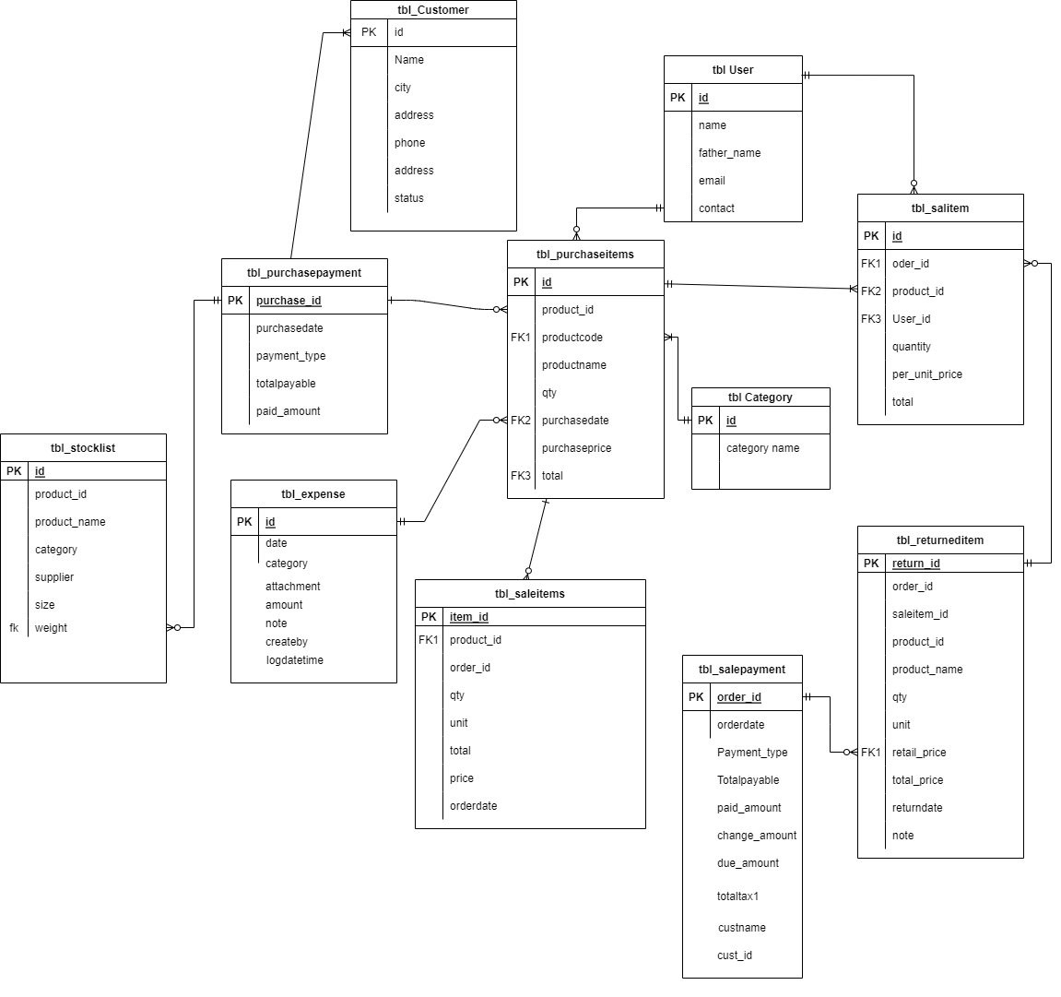

Fig 5: Entity Relationship Diagram

### 4.5 PROTOTYPE APPLICATION

The Sales and Inventory Management System is a desktop application that runs in a window. The program is developed in such a way that it may be used by persons with no technological knowledge by simplifying the functions. Figure 6 depicts the login page, which is the main page. The functionalities available while utilizing the application will be differentiated by the user and admin logins. Users will be brought to the content menu interface after successful login.

User can login in Payroll Management System as admin and user.

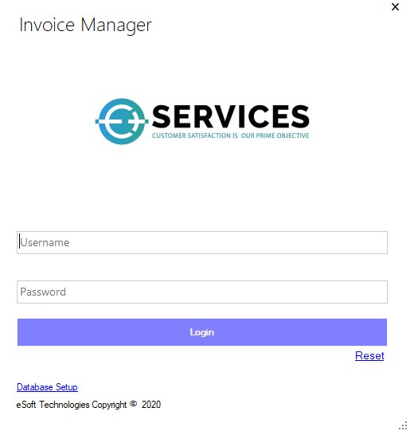

Figure 6: User Login Page

This is the system's home page. Users log in to the system using their 'Username' and password combination. They won't be able to log in if they don't do so. They are unable to use the system.

Figure 7 depicts the admin view's content interface. Admins have the option of selecting all four functionalities on the menu page: POS, Notifications, Inventory, and Reports. However, due to the security of shop information, only the POS button is enabled for user login.

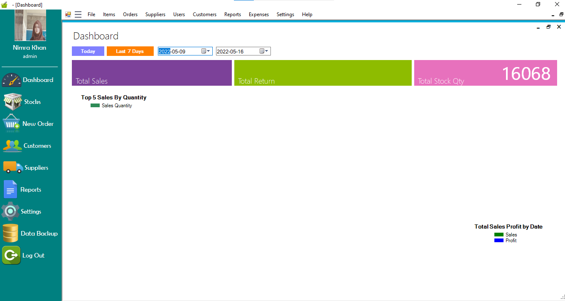

Figure 7: Content Page (Admin View)

When an administrator clicks the POS button, they will be taken to the POS page, as seen in Figure 7. For each new point of sale, the sales ID will be displayed on this page.

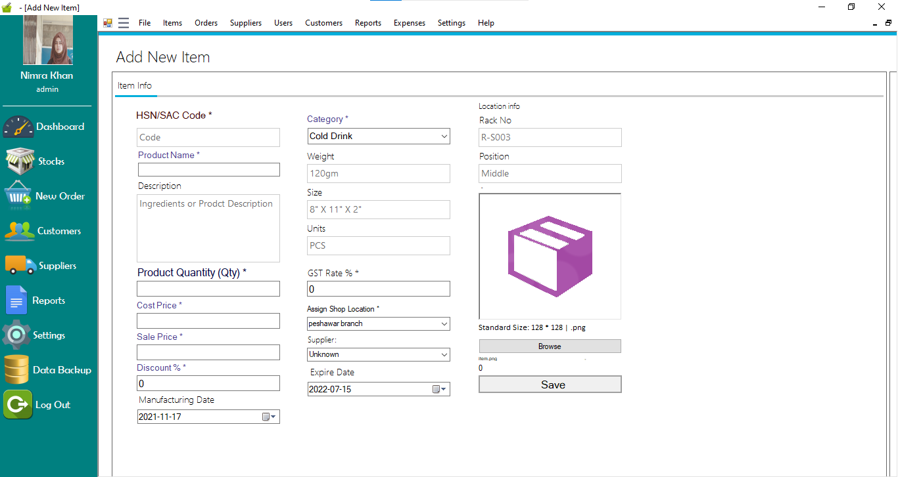

Fig 8: Add New Item

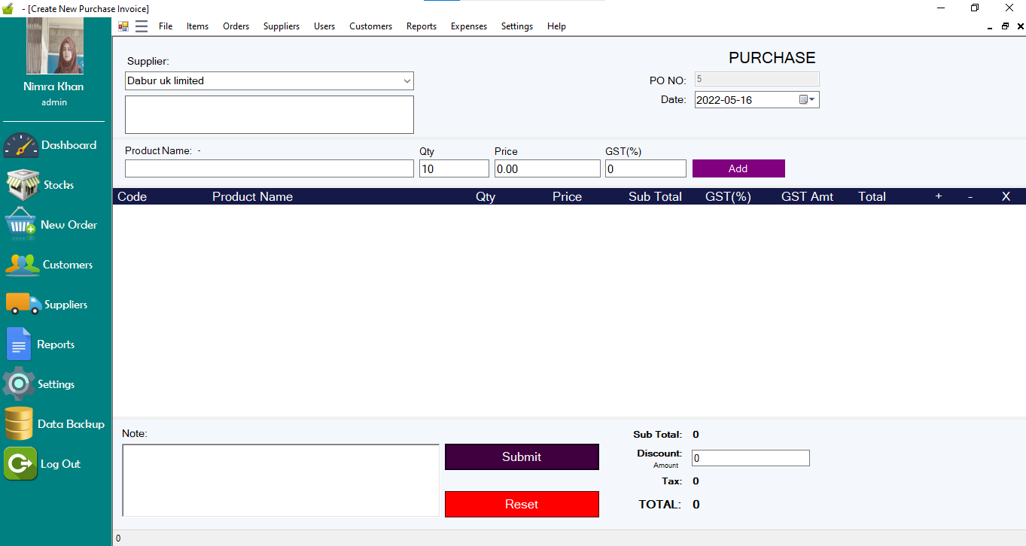Figure 9: New Purchase

*A purchasing system is a component of inventory management that can help businesses monitor and manage inventory.*

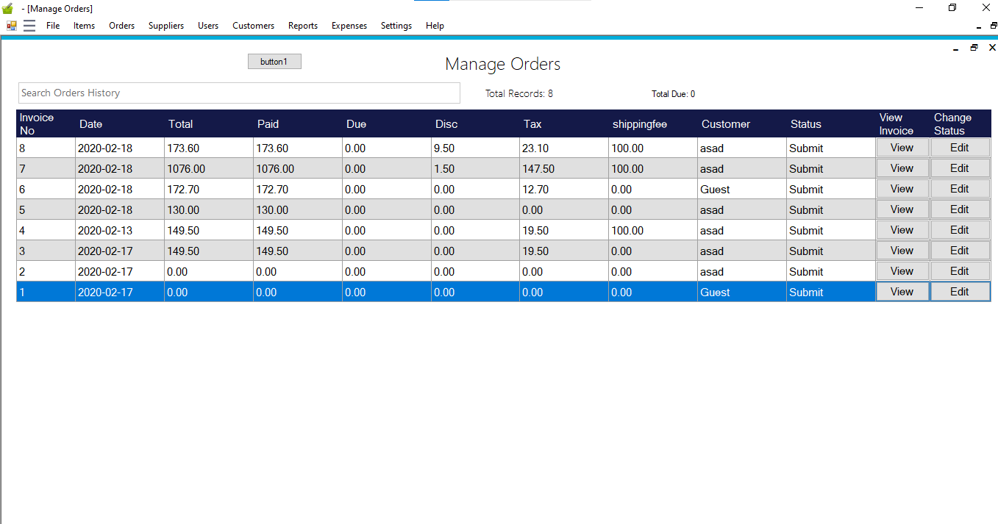

Figure 10: Manage Order

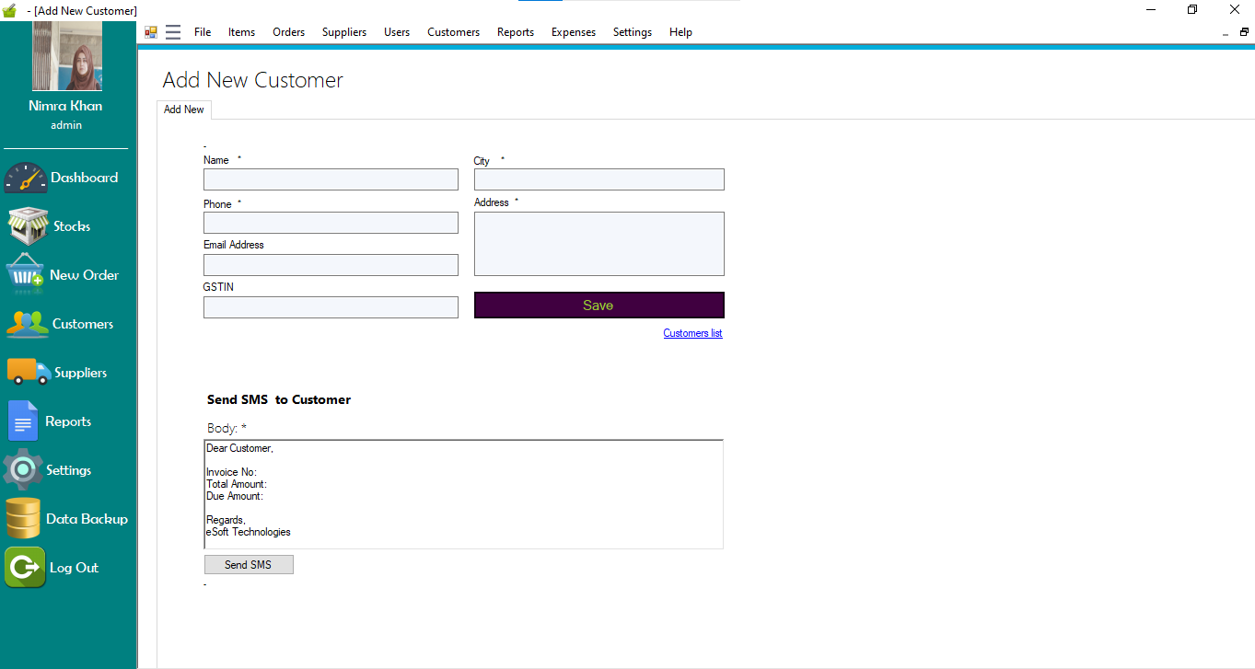

Figure 11: Add New Customer

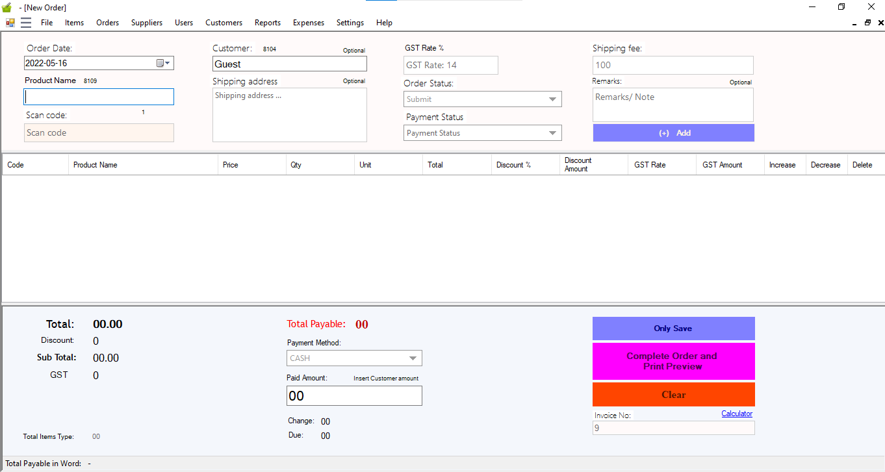

Figure 12: New Order

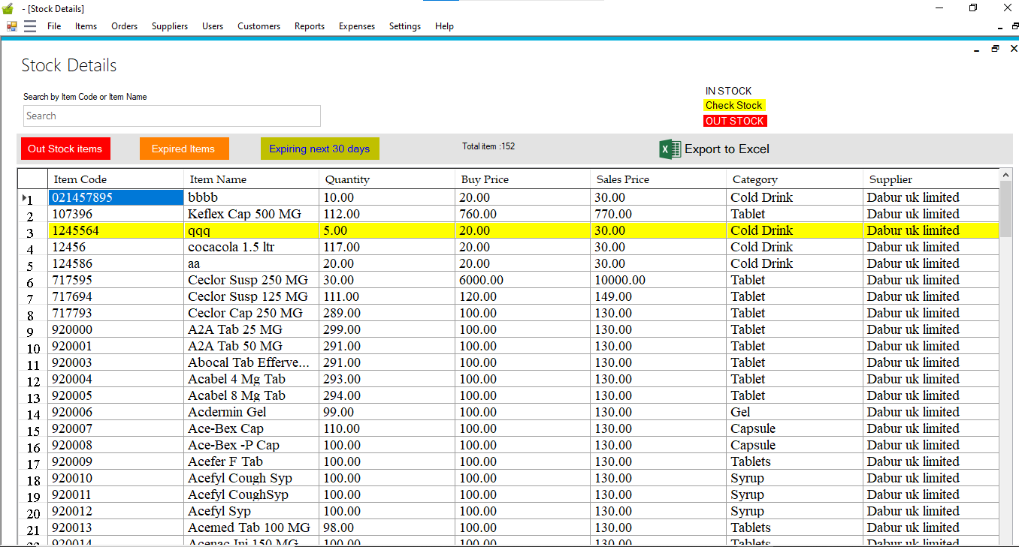

Figure 13: Stock Details

### 4.6 SYSTEM TESTING

Developer testing, user testing, and customer testing are the three parts of the system testing process.

1. ***Developer* *Testing***

The information entered by the administrator and the user is saved in a Microsoft Access database. Because transactions include a lot of database contacts, it's crucial to test the database's performance. To test the reliability of the constructed database, a set of 50 to 100 product records were inserted. In addition, the testing includes checks for syntax, functionality, and logical flaws. During this testing, no major issues were discovered.

***B.* *User* *Testing***

This testing takes place after the software has been developed. Users were given a crash course on how to utilize the system and interact with the UI. Users' comments about the system, such as software interface errors, functionality errors, command structure mistakes, and entry errors, were logged.

The procedure taken in conducting the user testing as below:

• System I and Traditional I users were separated into two groups. The System I received training and instructions on how to use the Sales and Inventory Management System to handle sales.

• Traditional I users attend to consumers in the traditional way, whereas System I users attend to customers in the traditional way. In the testing, the total number of transactions processed in a given time period was recorded

***Q1:*** ***What*** ***do*** ***you*** ***think*** ***about*** ***the*** ***system?***

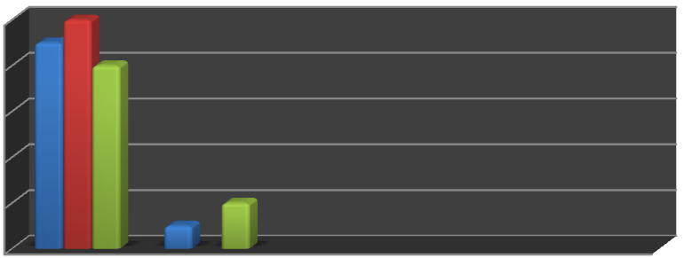

**No.** **of** **Respondent**



Figure 14: Effectiveness of System

The efficiency of the method is depicted in Figure 14. According to the diagram above,

All users agree that the technique makes detecting stock levels simple. The processes are clearly defined and easy to follow, according to 9 users, and 8 users believe that having the system will reduce POS errors.

***Q2: From*** ***your*** ***opinion,*** ***how*** ***does*** ***the*** ***system*** ***reflect*** ***the*** ***user?***

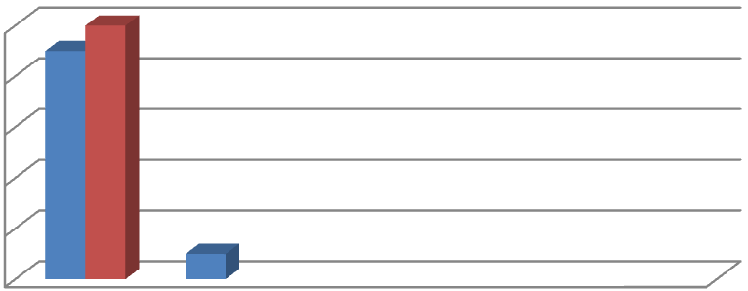

**No.** **of** **Respondent**

Figure 15: Reflection of System toward User

***Q3:*** ***What*** ***do*** ***you*** ***think*** ***about*** ***the*** ***sale*** ***report*** ***generated*** ***by*** ***the*** ***system?***

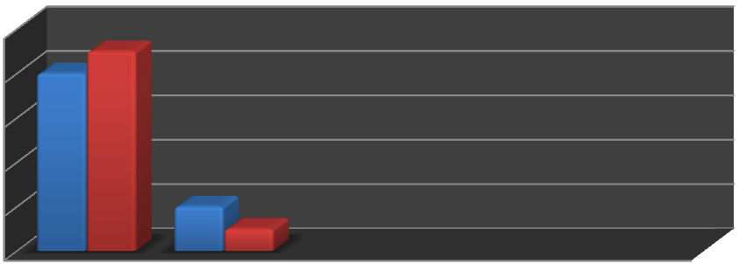

**No.** **Respondent**



Figure 16: Respond toward Generated Report

The users' reactions to the system's generated report are depicted in Figure 16. About 8 users thought the system's report was extremely helpful, and a total of 9 people thought the information might be used to make more decisions about product promotion in the real world.

***C.* *Customer* *Testing***

Customer testing is carried out to obtain feedback on the new sales system application. Essentially, users are provided a series of feedback forms on how they score the performance and speed with which the system processes transactions at the counter. During the testing, the level of client satisfaction was also taken into account



**No.** **of** **Customers**



Figure 17: Customer Testing Outcome

The outcome of the consumer testing is shown in Figure 17. The ranking is based on a scale of 1 to 5. A score of 1 indicates strong agreement, while a score of 5 indicates severe disagreement. Customers are satisfied with the system in terms of issuing valid receipts and calculating the correct total cost, according to the findings. They also strongly agree on the system's efficacy in terms of lowering the time it takes to process a sale at the counter.

## **CHAPTER 5**

### CONCLUSION

In conclusion, the project is relevant to the goals established. The project is currently in progress the design was based on a preliminary study conducted with Store. Thus, the planning and analytical operations of constructing the system are based on the results obtained from the observational interview. Not only that, but because this would be the store's first computerized system, the functionality was limited to addressing one significant issue: inventory management. Because the workers do not have an IT experience, the interface design is also characterized as user friendly, implying that the system can be used by persons who do not have an IT background.

The developer is unable to implement several features due to time restrictions.

As a result, the developer has a limited number of future work proposals for the system. First and foremost, the construction of integration between the system and the Store's supplier system.

Second, the system's decision support functions must be implemented. For instance, data mining techniques or approaches can be used to investigate sales patterns. The result of the pattern analysis might be used by the store to create marketing strategies for its customers or even stock arrangement management. All of this is expected to increase the store's sales beyond what they are now. Finally, in order to be competitive in the sector and against supermarkets such as Tesco and Billion, who are expanding in Taman Maja, the store must change its ways of doing business.

### REFERENCES

1. Deloitte (2012), The Changing face of retail Retrieved 18, Jun 2013.

2. Tim Crosby (2007), How Inventory Management Systems Work Retrieved 22, Jun 2013.

3. Wikipedia (2013), Inventory Management Software Retrieved 22 Jun 2013.

4. Anton Dolin sky (2007), Barcodes, sales and inventory control Retrieved 22 Jun 2013.

5. Evenson& Yves Daley (2010), The impact of the use of RFID on

6. supply chain operations Retrieved 30 July 2013.

7. Prototype development (image), *Taken* *from* *(Dennis,* *Wixom,* *&* *Roth,* *2006,* *p.* *14)*

8. Andre Homberg(2011), *User(image)* Retrieved.

9. *Grocery* *Shopping:* *Why* *It’s* *NOT* *a* *Man’s* *Chore* *(image)* Retrieved.

10. Prebills Prof Ed Retail Pos Software screenshot(image) Retrieved from

11. Pacific Amber Technology, *Reporting* *(image)* Retrieved from

12. Tim Zi Erden (2009), *4* *Keys* *to* *Inventory* *Management* Retrieved on 27 July 2013.

13. Edward A. Silver (2007), *Inventory* *Management:* *Practical* *Applications* *and* *Suggestions* *for* *Future* *Research,* Retrieved on 20 July 2013.

14. Zip kin, P.H., 2000. Foundations of Inventory Management, McGraw-Hill, New York.

15. Kaplan, Karen. "Do-It-Yourself Solution: Small Grocery Chain Has Big Plans for Its Retailing Software", ["Los Angeles Times"](http://en.wikipedia.org/wiki/Los_Angeles_Times), November 29, 1995, Retrieved on 12 August 2013

16. Tim Banjari (Jun,2013) *Bringing* *the* *Checkout* *Counter* *to* *You*, Retrieved on 12 August 2013.

*17.* Quarrion (August, 2011), [*The* *Unique* *Benefits* *of* *Having* *POS* *Systems,*](http://quorion.wordpress.com/2011/08/27/the-unique-benefits-of-having-pos-systems/) Retrieved on 13 August 2013.

### APPENDICES

**Interview** **Questions:**

1. What is the current approach for keeping track of inventory levels?
2. What is the procedure for selling to customers?
3. What are the store's inventory management issues?
4. Did buyers express dissatisfaction with products that were out of stock?
5. How do you keep track of the store's performance?
6. What if the consumer wants to return the item they bought?
7. How do you know whether a product has expired in the store?
8. Why do you think you should never employ a system in your business?
9. Will you employ a method to assist you with inventory management?
10. What are your expectations for the system to be developed?

**Sales and Inventory Management System (USER)**

This questionnaire is to evaluate the satisfaction and reactions to the new developed system.

**Instruction:** Please tick your answer

***1-*** ***Strongly*** ***Agree***; ***2-*** ***Agree***; ***3-*** ***Neutral***; ***4-*** ***Disagree***; ***5-*** ***Strongly*** ***Disagree***

|  |  |  |  |  |  |
| --- | --- | --- | --- | --- | --- |
|  | **(1)** | **(2)** | **(3)** | **(4)** | **(5)** |
| **User** **Friendliness** |  |  |  |  |  |
| ***1.*** ***Based*** ***on*** ***the*** ***experience*** ***using*** ***the*** ***system,*** ***are*** ***you*** ***satisfied*** ***with*** ***the*** ***interface?*** |  |  |  |  |  |
| a. The location of button is suitable |  |  |  |  |  |
| b. It is easy to navigate within the system |  |  |  |  |  |
| c. The font can be easily read |  |  |  |  |  |
|  | | | | | |
| **Effectiveness** **of** **System** |  |  |  |  |  |
| ***2.*** ***What*** ***do*** ***you*** ***think*** ***about*** ***the*** ***system?*** |  |  |  |  |  |
| a. Steps clearly stated and easy to follow |  |  |  |  |  |
| b. Staff/Admin can easily detect stock level |  |  |  |  |  |
| c. Staff/Admin encounter less error during POS |  |  |  |  |  |
|  | | | | | |
| **Use** **Intention** |  |  |  |  |  |
| ***3.*** ***From*** ***your*** ***opinion,*** ***how*** ***does*** ***system*** ***reflect*** ***the*** ***user?*** |  |  |  |  |  |
| a. I believe that the system would benefit the store |  |  |  |  |  |
| b. I intend to use the system when it is deployed |  |  |  |  |  |
|  |  |  |  |  |  |

|  |  |  |  |  |  |
| --- | --- | --- | --- | --- | --- |
|  | **(1)** | **(2)** | **(3)** | **(4)** | **(5)** |
| **Generated** **Report** |  |  |  |  |  |
| ***4.*** ***What*** ***do*** ***you*** ***think*** ***about*** ***the*** ***sale*** ***report*** ***generated*** ***by*** ***the*** ***system*** |  |  |  |  |  |
| a. The result generated by system is very helpful |  |  |  |  |  |
| b. The report is applicable |  |  |  |  |  |

**Sales and Inventory Management System (CUSTOMER)**

This questionnaire is to evaluate the satisfaction and reactions to the new developed system.

**Instruction:** Please tick your answer

***2-*** ***Strongly*** ***Agree***; ***2-*** ***Agree***; ***3-*** ***Neutral***; ***4-*** ***Disagree***; ***5-*** ***Strongly*** ***Disagree***

|  |  |  |  |  |  |
| --- | --- | --- | --- | --- | --- |
|  | **(1)** | **(2)** | **(3)** | **(4)** | **(5)** |
| **1.** **Performance** |  |  |  |  |  |
| a. Is the system perform better than older method used |  |  |  |  |  |
| **2.** **Satisfaction** |  |  |  |  |  |
| a. It is more organized in processing my sale |  |  |  |  |  |

**Effectiveness** **of** **System**

10